

**KIET Group of Institutions, Ghaziabad**

***Information Technology***

**Internship Report**

**on**

**Content Writing and Graphic Designing**

**Summer Internship at Vyamanik Aerospace**

**June**

**(2020)**

**Submitted By: -**

Shashank Singhal

B. Tech (IT)

1802913152

**ACKNOWLEDGEMENT**

I’ve got this golden opportunity to express my kind gratitude and sincere thanks to my Head of Institution, KIET Group of Institutions of Engineering and Technology, and Head of Department of Information Technology for their kind support and necessary counselling in the preparation of this project report. I’m also indebted to each and every person responsible for the making up of this project directly or indirectly.

I must also acknowledge or deep debt of gratitude each one of my colleague who led this project come out in the way it is. It’s my hard work and untiring sincere efforts and cooperation to bring out the project work. Last but not the least, I would like to thank my parents for their sound counselling and cheerful support. They have always inspired us and kept our spirit up.

**Shashank Singhal**

**B. Tech (IT)**

**5th Sem**

**1802913152**

**CERTIFICATE**

This is to certify that the internship project report entitled **Summer Internship at Vyamanik Aerospace** submitted by **Mr. Shashank Singhal** in the Department of Information Technology of KIET Group of Institutions, Ghaziabad, affiliated to Dr. A. P. J. Abdul Kalam Technical University, Lucknow, Uttar Pradesh, India, is a record of candidate summer internship. He has successfully completed his internship under my supervision and guidance and is worthy of consideration for the same.

**Signature of Supervisor:**

**Supervisor’s Name:**

**Date:**

**Index**

1. Company Profile
2. Overview of Project.
3. Introduction of Project Internship.
4. Details of task/s assigned
5. Details of Technical learning during delivery of task
6. Conclusion or Outcome of Internship
7. Future scope of work
8. Certificates of Moocs.
9. Review report of 5 research papers.

**Vymanik Aerospace**

Vymanik Aerospace Solutions LLP is a freshly incorporated company in 2017.

The aim of Vymanik Aerospace is to provide advanced technological services to the humanity through the process of Research & development, Education. We focus on Aerospace/ Aeronautical and Mechanical solutions the most.

The company is committed to equal or exceed standards are that are currently followed or demanded by the tech giants in the Aeromechanical sector.

Vymanik Aerospace believe in profitable, sustainable and enjoyable long-term relationships with employees and clients.

**Overview of Project**

The project for Summer Internship was to create viable content for social media handles of the company. The aim of the task was to get a better audience attraction towards the content and website traffic which may be turned into probable customers of the future.

Since social media is one of the most efficient way of increasing the company reach and create awareness. A dedicated resource for Social Media is a thing of present and every organization is doing. Internet has changed the way of business and one must adapt with things.

**Introduction of Internship**

Summer Internship at Vymanik Aerospace started on 26th May’ 2020. The initial task was to prepare a power point presentation to create some awareness about the company and what purposes the company have. The work escalated with division of work based on expertise and interest of individuals. The work needed to be submitted every day.

Initial work consists of writing marketable posts for the company. A blog with photoshopped images and a user-friendly text to attract the viewers over the social media.

Later on, I was assigned to create graphical content for social media handles of the company.

**Details of tasks assigned:**

I have been assigned with 2 tasks by the company representative. The two tasks were: -

1. Blog Content Creation

Covered various topics about Drones and their uses. Had to write 2 posts daily and make them attractive for the audience to read.

1. Social Media Post Creation

Created Graphical Contents related to drones and aviation industry.

**Details of Technical Learning During the Internship**

Learning is a continuous process. This internship helped me to revise the basic things which required brushing up.

1. Google Dorking

A skill of getting accurate results on Google Searches in less time. Since the topics were a bit uncommon. I had to apply some search filters to get exact information about the topics.

1. Graphic Design using Canva

Appealing graphics in no time using Canva. Used for designing better User Interface and User Experience too.

**Conclusion of Internship**

The summer internship was a good experience and ended up with a lot of learnings and additional skills. Now I’m confident about designing User Interfaces of my Mobile Applications. The blogging and Technical writing I did, now I can file proper documentation which is the first step for every production level project.

**Future Scope of Work:**

In the summer internship, the tasks were different from what we do in college and helped unlock several probable professions that can be taken up in the future. To name a few: -

* Content Writer
* User Interface Designer
* Graphics Designer
* Blogger
* Social Media Advertiser

Though these are non-technical job profiles. They have shown a promising future to the world in the recent years with the spike in Internet use and Smartphones.

**MOOC Certificates:**

1. **Flutter**

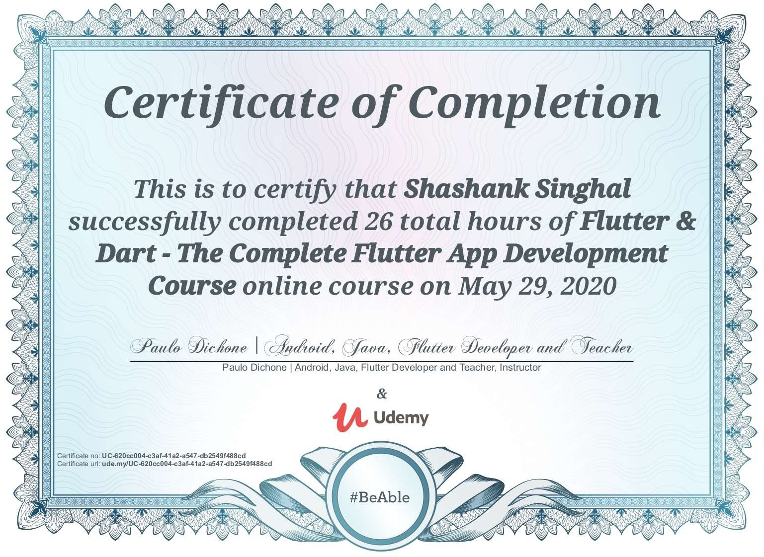

<https://www.udemy.com/certificate/UC-620cc004-c3af-41a2-a547-db2549f488cd/>

1. **Python**

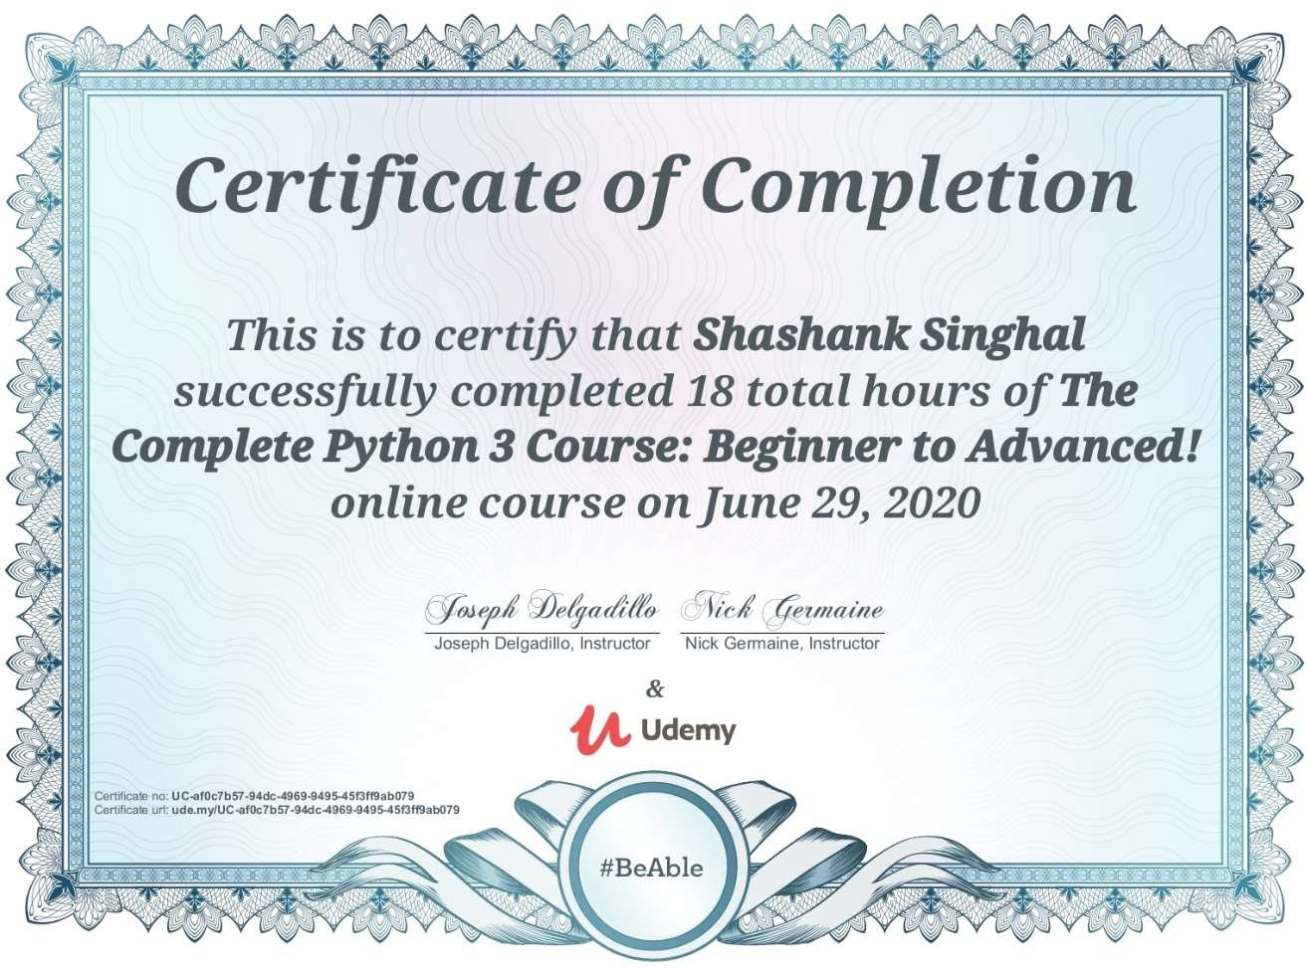

<https://www.udemy.com/certificate/UC-af0c7b57-94dc-4969-9495-45f3ff9ab079/>

**Research Paper Review**

*Paper 1: - How smartphones are changing the face of mobile and participatory healthcare: an overview, with example from eCAALYX.*

## Review:

With the rise in number of smartphone users globally. Almost every Industry is trying to get its hold onto its consumers via smartphones. Everyday, most of the time is spent being connected to Internet via smartphones as they are very handy. With increasing capabilities of a smartphone, it wouldn’t be wrong to compare it with a powerful computer. Everyday tasks can be done easily on smartphone and they also come with a bonus factor of mobility.

Modern day smartphones come with a wide variety of sensors housed inside them and health features to keep a track of every moment the user take. Also, in the recent years, there’s a massive up rise in fitness gadgets in the market ranging from smart wearables to trackers.

Seeing the unbreakable bond between users and their smartphones. The idea is created for betterment of healthcare features of a human being. With the smartphone app accessible by everyone. One can easily investigate the details and everything a person need to see. Also, some people who needs to be taken care of 24*7 can be easily served with Smartphone Healthcare Apps.

Aside some minor challenges and usability issues. Smartphones have unlocked a completely new potential for practically every business and service. Many healthcare facilities are taken up online and they will surely grow more and more in number with the upcoming future.

*Paper 2: - An Efficient Android-Based Multimodal Biometric Authentication System with Face and Voice.*

## Review: -

There’s an all-time high in digital payments and virtual currencies. A time where privacy is everything to a person. Hackers try everything to exploit data from devices of the unaware people. When our smartphones can do so much for us including handling our bank accounts and payments. We need a better quality of security for unlocking our devices and authentication.

We are using Unimodal Authentication System which uses just a single type of check for authentication. For example, we have passwords, pins and patterns. These are not secure and can be easily broken down with brute force methods and general guessing.

There is a need for multi-layer authentication system technically called as Multimodal Authentication System. There are various multimodal authentication systems present in the market but are not incorporated in every device simply due to cost factor. For example, we have, retina scan, fingerprint scanner with heart-wave sensor etc.

Recently, the new face unlock has seen a great potential in the market. Though not completely safe. Face Unlock eliminates many processes incurred by the CPU and RAM, it isn’t a very safe and reliable option out there. In this paper, A new authentication method is brought up which is a combination of face and voice unlock. To authorize any transaction a user, must face the camera and say a previously set sentence. If the voice and face matches, the authentication will be processed else it won’t.

*Paper 3: -How Can Artificial Intelligence Help with Space Missions.*

## Review: -

Several years after the first moon landing, experts are now looking at emerging technologies to understand the space exploration a little better. With recent breakthroughs and discoveries, AI has been showing immense potential in space exploration, such as global navigation, earth observation, and communications to and fro. Historically, machine learning algorithms have been used in monitoring the spacecraft, autonomous navigation of the spacecraft, controlling systems, and intelligently detecting objects in the route. And now, in a bid to help astronauts, AI- based assistants are being created to aid astronauts in their missions to Mars and beyond. These assistants are designed to understand and predicts the requirements of the crew and comprehend astronauts’ emotions and their mental health.

AI has positioned itself as a game-changer, even for the space industry. The governments and agencies have been leveraging AI technologies, since a long time, to gather imaging data related to space exploration. Robotica is also seen to be used by government agencies to conduct modern surveillance, identify and mitigate risks, and to analyses the substantial amount of collected data.

According to the European Space Agency (ESA), satellites can produce over 150 terabytes of data per day. With the use of AI technologies, one can reduce the mission costs, extend battery life, and can analyses a vast amount of imaging data produced by the satellites. Earth Observer 1 (EO-1) satellite, SKICAT, ENVISAT are a few of the satellite examples around that uses AI to provide actionable insights for agencies, governments and businesses, and help them in making accurate decisions.

*Paper 4: -Phishing-Alarm: Robust and Efficient Phishing Detection via Page Component Similarity.*

## Review: -

Phishing is an age-old technique of scamming users with their private information like usernames and passwords. We have stepped into the digital era where information is all digital and secured with just a combination of alphanumeric characters and symbols.

A phishing page is a carefully designed and socially engineered page which lures the users and trap them into believing that the spam page is the real page. Though, the hit ratio of Phishing is comparatively low due to multiple checking factors available. It is still one of the most widely user Cyber Attack.

There are number of counter phishing methods available in the market which protects many users from being scammed every day. To name a few, we have URL Based Detection, Content Based Detection etc. but attackers have multiple leverages and ways to overcome these by making exact replicas and URLs.

In this paper, the writer presents another method to prevent phishing attacks which uses appearance-based detection. Generally, a webpage layout is set using Cascading Style Sheets (CSS). The way a webpage is rendered on different web browsers and machines is a peculiar thing and comparing this web view, the presenter of the paper has designed a phishing alarm.

The above-mentioned solution is presented in the form of Google Chrome extension and demonstration have been done for its effectiveness in the real world.

*Paper 5: - A Session and Dialogue-Based Social Engineering Framework.*

## Review: -

Social engineering is the art of manipulating people, so they give up confidential information. The types of information these criminals are seeking can vary, but when individuals are targeted the criminals are usually trying to trick you into giving them your passwords or bank information, or access your computer to secretly install malicious software–that will give them access to your passwords and bank information as well as giving them control over your computer.

A complete social engineering attack is defined as Social Engineering Session (SES), while a part or phase of SES is termed as Social Engineering Dialogue (SED). A SES consists of many carefully planned SEDs.

Social Engineering ranges from simply guessing the details about the person to carefully planned details extortion for a heist. A social engineered scam may look like an email from your friend. A message from your bank or A cry for help.

A newer method of social engineering has surfaced where a Google Form is sent to many users to form a database of user’s information and email listing. Social Engineering is still in its initial phase and there are vast research going on in the field.

General people must be aware about these malicious practices and should not provide their personal details on Social Media. You never know who gets the clue about your personal life from the posts and stories you create and hack into your systems with a weak password and security question you’ve set up.